Observations / Comparaisons for the Part II Exercices

Benchoubane Sid-Ali

Exercice 1 :

The graph shows that the Car dataset gets better accuracy than Tic-Tac-Toe as the tree depth increases. The accuracy goes up for both datasets at first, but Tic-Tac-Toe starts to level off and drop a bit after depth 9, which means the tree might be overfitting. This shows that deeper trees work better for more complex data, but not for simpler ones, so yes in my opinion there is a relation among the size of datasets

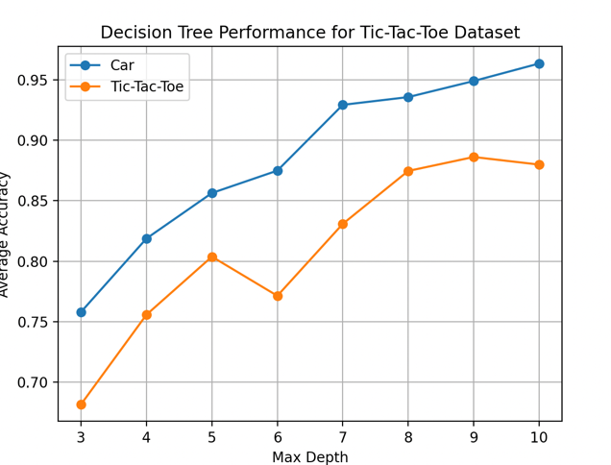

Exercice 2 :
This exercise confirms my observations from the first one, as it shows that with larger training data sizes, the classifier’s accuracy improves (exponentially), stabilizing after a certain point. Smaller datasets, on the other hand, lead to lower and more variable performance, supporting the idea that larger, more representative datasets help the model generalize better.
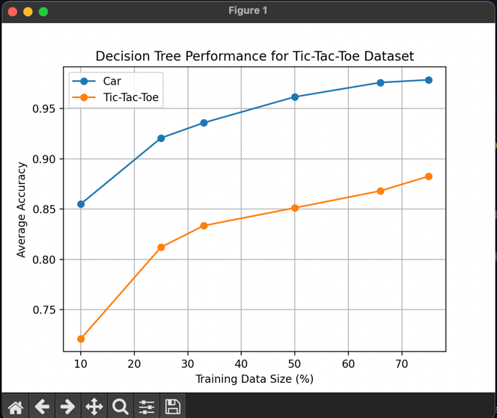

Exercice 3 :
i generated the four linkages methods with the help of dendrogram but i can’t really explain how they work in the Agglomerative Clustering method, i maybe made a mistake as i see the distance at which clusters are merge dis a bit the same…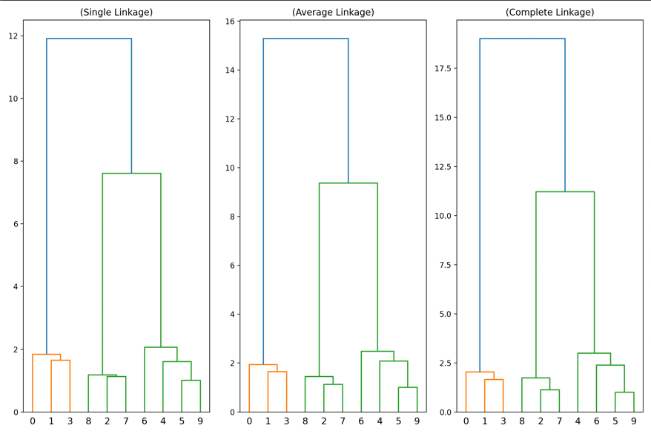

Exercice 4 :
K-means produces more evenly sized clusters based on centroids, while Agglomerative Clustering is more flexible, adapting to the data’s structure and forming uneven clusters.

Exercice 5 :
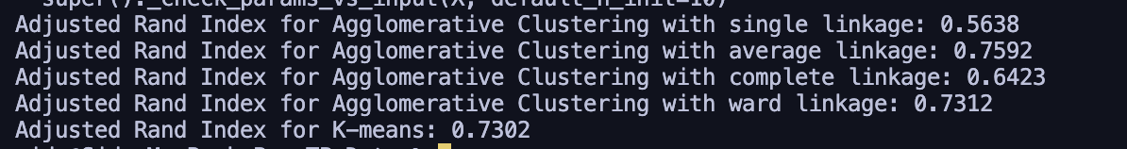
Average linkage and ward linkage performed the best in matching the true labels of the Iris dataset, with average linkage giving the highest score. K-means also performed similarly to ward linkage, indicating it works well for this type of data. On the other hand, single linkage performed the worst, likely because it creates irregular clusters that don’t match the true structure of the data.

